QUIZ RESULTS
MODULE2: DISTANCE MATRICS & COMPUTATIONAL HURDLES

No. | Quiz title | Completion Status | Score | Coursera link
1 | Module2_1_Distance Metrics | Completed | 100% | Quiz 1
2 | Module2_2_Module 2 Quiz | Completed | 100% | Quiz 2

Module2_1_Distance Metrics
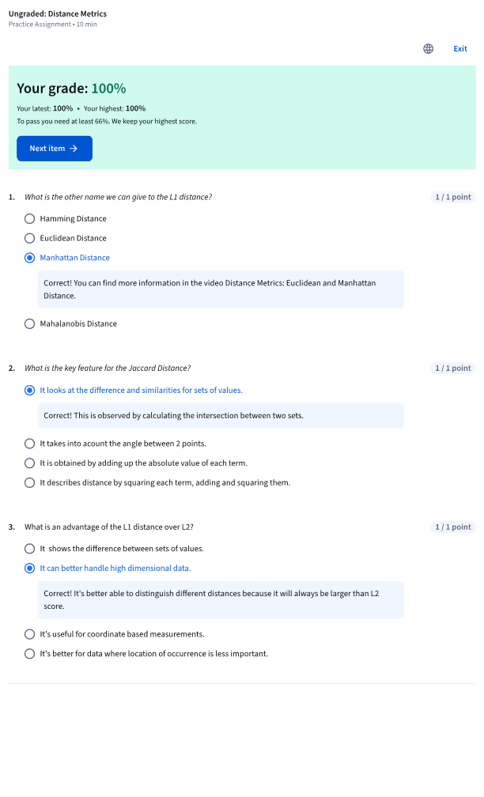

Module2_2_Module 2 Quiz
